REQUIREMENTS ELICITATION :

Definition : It is a communication process involving different communities.
- Elicitation takes place through meetings, interviews, Telephonic conversation, Email, Video Conferencing.

REQUIREMENTS ELIC ITATION STEPS -

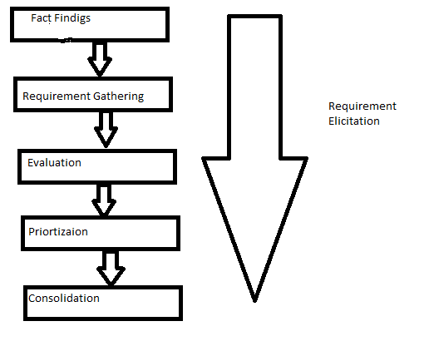

FLOW OF REQUIREMENT ELICITATION

1.Fact Finding:
- Identification of relevant users.
- Identification of analyst with the relevant domain.
- Determination of scope.
- Identification of similar systems.
- Technology Survey.
- Assessment of cost.

2. Requirement Gathering : There are many elicitation techniques for gathering the requirements. Classifies a wish list according to Functional and Non-functional requirements.

3.Evaluation: Requirement gathered need to be evaluated why it has been stated?
- For every Z - requirement get the answers to the questions . why do you need this requirement?
- Perform Risk Assessment, Feasibility and cost benefit analysis.

4.Priortization : High priority requirements can be addressed first.

S.NO | Requirements | Benefit of user | Ease of Deployment | Ease of Development | Independent from other requirements | Total
1. | Shoppin cart-login | 9 | 7 | 7 | 8 | 31
2. | Web logo | 8 | 6 | 7 | 9 | 30
3 | Items are here
4 | payment

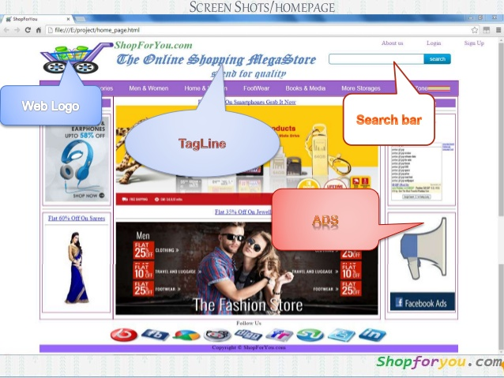

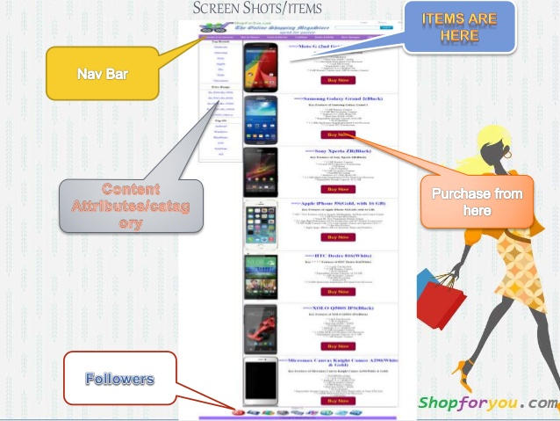

- The requirements which depend on other requirements will down in priority table.
Requirement Elicitation Techniques are:
CORE: Controlled Requirement expression
IBIS: Issue Based Information System
FODA: Feature oriented Domain Analysis
JAD: Joint Application Design
Prototyping: Roughly & rapidly developing model
QFD: Quality Function Deployment
SSM: Soft System Methodology
CORE is a view point based method. Any system is viewed from a number of viewpoints & complete picture of system requirements can only emerge by various view points
- View points in CORE include both functional and non functional, they are identified by partitioning the problem.

- Step1: view point identification
- Step2: selection
- Step3: view point analysis - to understand the data, view point actions
- Step4: Isolated threads
- Step5: combined thread, to put together in a sequence.
IBIS
- This developed by Horst Riffle,
- any problem to be solved as many stakeholders involve with different views Dialogue required resolve various issues. This technology focuses on discusses to identifying & resolving the issue
- Frameworks used in IBIS are:
- Question (issue)
- Idea (response)
- Argument (justification)

Question: How do we inform the customes about the status of their custom complaints ?
Idea : Send e-mails
Question: how often
Idea: Every day
Argument: Too infrequent in some cases
Idea : Call them over phone
Dia(a) Sample IBIS documentation
FODA:
Based on domain
- Context analysis
- Domain modeling
- Architecture modeling
- CA: This defined the boundaries of the domain for analysis
- DM: describes the problems space in the domain to be addressed by the software
AM: This gives the software architecture for implementing solution.

